Adverse Weather Policy

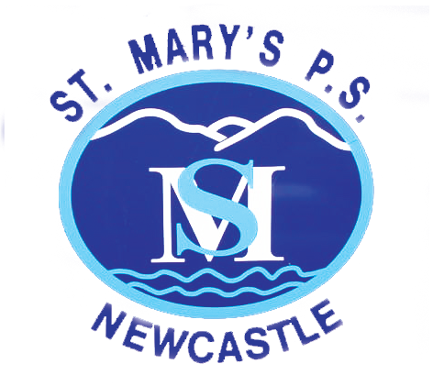

St. Mary’s Primary School and Nursery Unit

**Purpose**

* To make clear the policy and procedure in relation to operating the school during adverse weather conditions
* To make clear the grounds for school closure due to adverse weather conditions
* To advise and inform staff and parents of the systems and procedures in place in the event of a school closure due to adverse weather conditions

**Policy Statement**

It is the aim of St. Mary’s Primary School and Nursery Unit to ensure that the school remains open during adverse weather conditions, including floods, whenever practically possible, providing this can be done in a safe manner that does not give rise to danger of users of the site. Policy at St. Mary’s Primary School and Nursery Unit is to wherever possible, make the decision about school closures as early as possible.

**Health and Safety Responsibilities**

St. Mary’s Primary School and Nursery Unit has a duty of care to anyone coming onto the school site and would be liable if it was found that the school had been negligent in its responsibilities and hadn’t taken all reasonable measures, given the circumstances, to ensure the Health and Safety of pupils, staff, visitors and parents entering the school site. It is the Principal and Vice Principal who are ultimately responsible for ensuring safety on the school site in accordance with the school’s Health and Safety policies and procedures.

**Site Specific Considerations**

In the event of snow or ice some pathways will be cleared and salted. Pupils, staff, visitors and parents should be aware that pathways, even where attempts have been made to clear and salt, do remain dangerous. Children will also be reminded of this in assemblies and class. Before and after school opening hours, parents are responsible for ensuring their children do not slide on the school playgrounds.

In icy conditions the Building Supervisor will salt pathways as follows:

* From the main front gate (Elmgrove Park) to the Nursery School and the main School Reception door
* From the rear school entrance (Dunwellan Park Gate) to the Nursery School and the main School Reception door

Where necessary, essential pathways will be maintained as clear as possible throughout the day.

**Decision to close**

The decision to close the school either before or during the school day will be made by the Principal or in his absence the Vice Principal. The school will only be closed if one or more of the following conditions apply:

* Insufficient staff are able to come in to keep the school running safely
* Conditions on site are dangerous
* Conditions are considered to be or are anticipated to later become too dangerous for travel

Closures will be reported on ‘MY-SCHOOL’ as an “Emergency School Closure Notification”. C2K, on behalf of St. Mary’s Primary School and Nursery Unit, will then inform BBC so emergency closures can be recorded on BBC News NI and BBC News NI Live on [www.bbc.co.uk/news/live/uk-northern-ireland-34506293](http://www.bbc.co.uk/news/live/uk-northern-ireland-34506293)

This Live page operates Monday – Friday except during school or public holidays. If a significant number of schools decide not to open they will be included in a list on the BBC News NI website at [www.bbc.co.uk/newsni](http://www.bbc.co.uk/newsni) Information will also be carried on BBC Radio Ulster 94.5FM.

Parents will be alerted to any school closures once a text has been activated by the school Principal or the Vice Principal. The school will make all practicable efforts to keep parents informed as to the situation with the school during adverse weather conditions as we appreciate that such conditions and the uncertainty, places considerable difficulties upon parents.

In the event of the school having to close during the school day due to adverse weather conditions (or for any unforeseen circumstance), parents will be contacted via text message, social media and/or by telephone at home or at work, and will be asked to make arrangements to collect your child (ren) as soon as possible. In addition, and at the Principal’s discretion, staff living the furthest distance away may be allowed to leave with their colleagues asked to cover until children are safely collected from school. A closure of the school during the school day and an early release of staff will only be contemplated in very extreme circumstances.

Where the school is officially closed, all absence is counted as **authorised absence**.

**Where the school remains open in snow or ice**

When there has been snowfall or the school site is icy and the school remains open, access to the school grounds will be restricted in line with the “**Site Specific Considerations**” section. Pedestrians entering the school site are advised to stay on the main pathways which wherever practically possible will have been cleared and gritted.

During adverse weather conditions the playgrounds may be out-of-bounds to parents and children at the beginning and end of school. All persons entering the school building will be asked to wipe their feet on the provided mats as they enter to reduce the slip hazards caused by wet floors.

**Responsibilities in the event of a School Closure**

* In the event of adverse weather conditions, the Building Supervisor will assess the school site and inform the Principal at 7am of the state of the site
* The Principal will decide whether to close the school in consultation with the Vice Principal, SMT and the Chair of the Board of Governors
* The Principal will create an ‘Emergency School Closure Notification’ which will be collected by C2K. C2K will inform BBC News NI and BBC News NI Live
* The Principal or Vice Principal will contact Department of Education informing them of the proposed school closure
* The Principal will inform Staff and Parents by 7.30am via the School Text Service
* The Principal or Vice Principal will post an update on the homepage of the school website and the school’s social media sites (Twitter)
* The Building Supervisor will display a ‘School Closure’ sign on the main entrances to school
* Please read all notices – do not simply assume that school is open
* In the Principal’s absence all responsibilities of the above will be carried out by the Vice Principal in consultation with the Chairperson of the Board of Governors